**Compare Strings**

We can compare between two strings by 2 ways:

1. Comparison operators.
2. Stringname1.localeCompare(stringnmae2);

**Firstly**: by Comparison operators:

We use

1. = operator to check if the two strings are identical or not; where if they are identical **true** will returns else **false** will returns.
2. > & < operators to check which operator is larger than the other. By checking the alphabetically ordered ([Unicode order](https://unicode-table.com/en/#basic-latin)) of characters in the strings; where the string with lower alphabetically character is smaller than the string with higher alphabetically order and the verse. **If** both strings have common characters JS engine will check the 2nd characters, if they are also identical 3rd characters will be checked….etc.

**Example:**

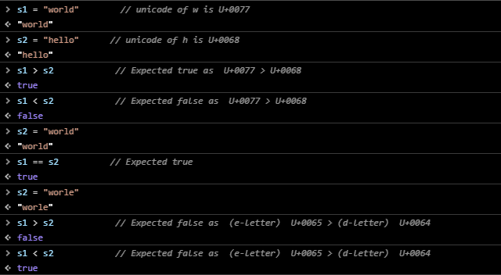

**Secondly:** by locale compare method.

**We use:** Stringname1.localeCompare(stringname2); to compare between two strings, if:

1. Two strings are **identical** return value is **0.**
2. Stringname2 is the **highest** in alphabetically order **(**[Unicode order](https://unicode-table.com/en/#basic-latin)**)** return value is **-1.**
3. Stringname1 is the **highest** in alphabetically order **(**[Unicode order](https://unicode-table.com/en/#basic-latin)**)** return value is **1.**

**Example:**

